Lecture 13

CPSC 131  
10/7/2020

1. Stacks and QUEUES
   1. To review
      1. They’re just wrappers for containers; not new containers
      2. Stack: LIFO
      3. Queue: FIFO
2. Example – Sketching a stack with singly linked list
   1. 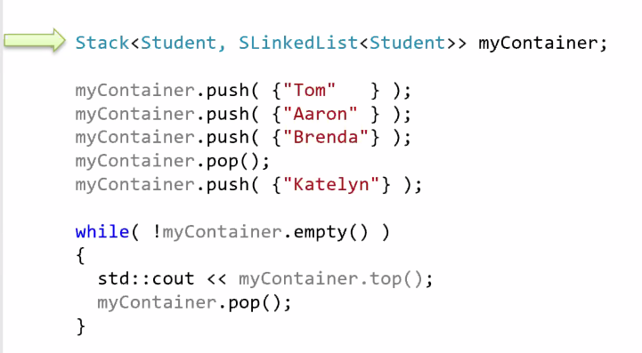  
      A close up of text on a whiteboard

      Description automatically generated
   2. Example same thing as above except with Vector

t (below table) = top  
t (side) = time  
s = size, c = capacity

* 1. Array  
     A close up of text on a whiteboard

     Description automatically generated
  2. DLL  
     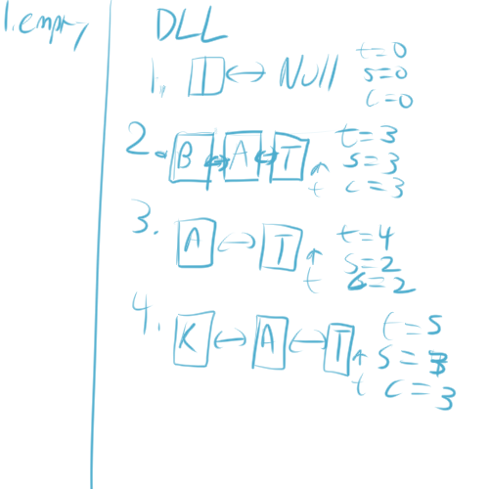
  3. DLL with dummy node  
     Text, whiteboard

     Description automatically generated
  4. DLL with 2 dummy nodes  
     